

**Bibliographic report – ROB 3**

***School year 2022-2023***

***Poly-Snake***

**Etudiant : Mascherpa Audric – Soufiani Younousse**

**Encadrants : Pascal Masson**

Ecole Polytechnique Universitaire de Nice Sophia-Antipolis, formation robotique (systèmes autonomes)

930 route des Colles, 06410 BIOT

**SUMMARY**

Introduction 3

Chapter I : Synthèse de l'existant 4

I.1. Introduction 4

I.2. previous project 4

I.2.1. Controlling snake-like robots 4

I.2.2. Bioinspired Robotic Snake 4

I.2.3. Snake Robot 5

I.3. Results 5

Chapter II : Specifications 6

Chapter III : System structure 7

III.1. Introduction 7

III.2. Specificity of the Poly-Snake 7

III.2.1. Camera 7

III.2.2. Ultrasonic transmitter 7

III.2.3. Rectifier 8

III.2.4. Motorization 8

III.3. Choice of engines 8

III.3.1. DC motor 8

III.3.2. Servomotor 9

III.4. Battery selection 9

III.5. Results 10

Chapter IV : Realization 11

IV.1. Assembly of the robot 11

IV.2. Filament choice 12

IV.3. Final appearance 12

Chapter V : Conception 13

V.1. Strategy 13

V.2. Planning 14

Conclusion 15

Useful link 16

**Introduction**

Snakes form a very special family of the animal kingdom due to their ability to move on the ground while being totally devoid of visible limbs. Indeed, these reptiles have learned to move by undulating their bodies which, thanks to the shape of their scales, allows them to move freely and without any constraint on any type of terrain. After having precisely analyzed their movement, we realized that it would be possible to reproduce this means of transport using the equipment provided by our establishment.

Thus, as part of our 3rd year project, we decided to design an Arduino robot with the same characteristics as a normal snake and to reproduce its means of movement.

This original project will allow us to manipulate and discover the world of robotics as well as the fundamental aspects that compose it such as: design, production, programming, etc…

However, to make our project understandable and easily accessible to a wide audience, it is important to come back to certain points of our summary as well as the sequence of this bibliography. Thereby:

* Initially, we will focus on the various projects like ours that have already emerged and how they work, all with a view to producing a synthesis of existing projects to be able to draw inspiration from them.
* Secondly, from the previous step, we will produce a specification of our system in order to facilitate the choice of the constituents of the Poly-Snake and to clarify our performance objectives for our system.
* Next, we will study the various structures envisaged for our project such as the assembly of the robot, the choice of these specificities or the motors and materials used for the design of the snake's body.
* Finally, we will focus on the design of the robot such as our strategy put in place for the realization of the project and the visualization of our schedule in broad outline.

Therefore, each of these steps will allow us to highlight our desired objectives, and the way we want to design our project during this year. However, it is important to take into account that all these notes are by no means definitive and that it is very likely that we will make mistakes that we will only notice along the way and that our final project will be, in many points, different from what we will describe later. Nevertheless, we will use this bibliography as a starting point allowing us to organize ourselves as much as possible and to make the project as concise as possible.

Finally, we will produce a summary at the end of this bibliography which will condense all the information cited in one paragraph to further simplify the understanding of our project and to summarize the essential points seen so far.

**Chapter I: summary of the existing**

**I.1. Introduction**

The objective of this first chapter is to carry out a "synthesis of the existing" of the Poly-Snake or, in other words, to list and analyze the most similar projects already existing in order to be able to have a look at what has already been done and to draw inspiration from it with the aim of making the most complete robot possible within the limits of our current skills.

**I.2. Previous project**

* I.2.1. Controlling snake-like robots



Surely the most complex project we will study, the Controlling snake-like robots is a snake robot capable of moving on all terrains and in all directions as we can see in Figure 1.1. Indeed this robot has the particularity of being divided in the form of several small modules attached to each other by spherical connections giving it the ability to twist and bend at different angles as we can see in the photo below. above.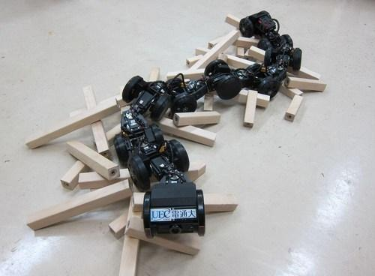

All placed on motorized wheels allowing it to move forward, the Controlling snake-like robot excels in its great mobility allowing it to overcome many obstacles and move over a wide range of terrain.

Although complex, this robot designer and designed by a group of Japanese engineers is an example in the matter giving us an overview of what is achievable and the many possibilities that we can implement in the Poly-Snake.

* I.2.2. Bioinspired Robotic Snake 

The Bioinspired Robotic Snake is a personal project extremely close to what the Poly-Snake could be.

Indeed, this robot has the particularity of this movement using 10 MG996R servomotors allowing it to undulate its body and move on the ground by sliding using small wheels positioned under the robot.

All controlled by an Arduino board and powered by a 25V battery connected to the end of its tail, this project has the advantage of being much easier to understand than the previous one and of giving us access to a lot of information such as the plans of the 3D printing of the parts connecting the servomotors to each other or even interesting ideas such as the possibility of raising the upper body of the Poly-Snake as we can observe in figure 1.2.

* I.2.3. Snake Robot 

Finally the Snake Robot is a project involving, like the previous one, the use of an arduino card and several servomotors in order to move the robot placed on small wheels using lithium-ion batteries which supply it as we can see in figure 1.3.Une image contenant intérieur, plancher, mur, bureau

Although this robot looks more simplistic than its predecessors, it is still a great example of what the Poly-Snake could look like and gives us an idea of how to design our project.

Indeed what is interesting to note here is that the robot has no motors to make it advanced, everything is at the level of the movement of the robot and the inclination of the wheels. Thus an analysis of the program and the position of the wheels could allow us to design the movement of the Poly-Snake ourselves without having to add a motor.

**I.3. Results**

Finally, the study of each of these projects allows us to visualize what the Poly-Snake could look like and potential ideas that could be interesting to implement in our project.

Nevertheless, before dwelling on the different aspects that our robot could take, it is important to visualize the performance objectives of our system by producing a specification.

**Chapter II: Specifications**

To facilitate the choice of components for the Poly-Snake, we decided to produce a specification summarizing all our objectives in terms of precision, speed, resistance, etc…

Thus, here are the criteria of requirements that stand out for the creation of our project:

|  | Function | assessment criterion | requirement levels |
| --- | --- | --- | --- |
| FC1 | Move | Progress | 0,05m/s |
| FC2 | Scout | Camera – Ultrasonic sensor | 1080p ; +29fps |
| FC3 | detect obstacles | Precision | ± 0,3cm |
| FC4 | The robot must fit in the trunk of a car | Size | 40 x 30 x 20 cm |
| FC5 | Aesthetic | Color - Form | Free choice |
| FC6 | Operate without mains connection | Battery | +4066 mAh ; +6V |
| FC7 | Autonomy | Getting Started - Autonomy | Botton ; [20 ;30 min] |
| FC8 | Must be adapted to the field | Resistance | Water - Shock |

**Chapter III : System structure**

**III.1. Introduction**

Now that the specifications have been completed, it is time to look at the internal part of the Poly-Snake. Indeed, our project will be composed of different "organs" allowing it to perform complex actions such as analyzing its environment, capturing images or even moving using a motor.

So, in order to facilitate the understanding of our system we will, during this chapter, briefly present the components that we can incorporate into our system as well as their operation. Then we will focus on the assembly of the robot and finally the different possible materials that we can use when 3D printing the parts.

**III.2. Specificity of the Poly-Snake**



* III.2.1. Camera

In order for our system to capture images of its environment, we sought to include a miniature camera. Thus, after some research our choice fell on the: InnoMaker Raspberry Pi Camera Module Wide Angle Lens 5MP 1080P OV5647 Sensor present in figure 2.1.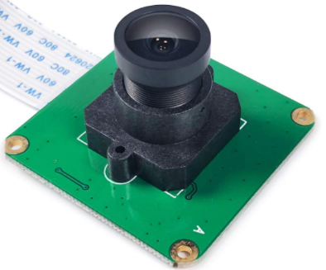

In addition to being small in size, this camera has a high resolution lens with a viewing angle of 160°, a good frame rate and an integrated zoom all for a very reasonable price. affordable, would be the ideal image capture tool for our project.  


* III.2.2. Ultrasonic Emitter

For the detection we opted for the use of an ultrasonic sensor, as shown in Figure 2.2, for its ease of use and its inexpensive price.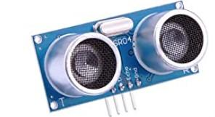

Indeed, it is quite easy to use under Arduino and offers ample precision for our system which will, as specified in the specifications, be keen to avoid obstacles within 10cm of it.

In addition, in the event that the lack of precision of the sensor would be a problem, we would always have the possibility of replacing this model with laser obstacle detection modules for Arduino or even with a SEN0413 lidar which, although more expensive, is turns out to be much more accurate than the sensor we chose.

* III.2.3. Rectifier

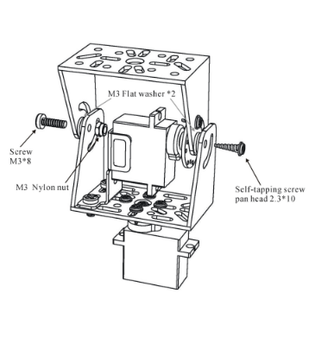

Also, one of our great challenges would be to give the possibility to our project to recover in order to overcome an obstacle, to change the angle of view or simply to imitate the attitude of a real snake.

So, we will need to design a part similar to the part in figure 2.3 taking into consideration the size of our servomotors as well as the efforts it will have to support. In conclusion, the part must be solid and light and will be produced by 3D printing.

The principle of the part is simple, it allows two rotations along two axes thanks to the use of two servomotors. In our case, this will allow the undulation of the snake in the first axis to avoid obstacles, but also the straightening of the snake in the second to be able to take a good shot.

* III.2.4. Motorization

In order to obtain, from our project, a movement that is both fluid and fast respecting the specifications that we have imposed on ourselves, we have opted for the use of motorized wheels allowing the Poly-Snake to move much more simply than with a simple wheel and more servomotors that we will use for the movement of the snake.

Thus, the movement of the wheels will have to remain simple, they will just have to be able to move forward and backward simultaneously in pairs and that is why we will take one motor for 2 wheels on each module except the head.

However, the choice of motors being crucial, we will see in the next part of this chapter the list of the different motors that we plan to use and why.

**III.3. Choice of engines**



* III.3.1. DC motor

N We first chose this type of motor for the motorization of the wheels due to the good torque combined with a reduction gear that it offers but also and above all for its relatively good precision depending on the models like the one in figure 2.5.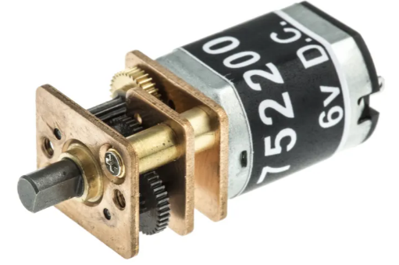

Thus, according to our research, the DC motors that we have considered using and which would best correspond to our performance criteria are the RBC-Apt-90, the FIT0503 and finally the RS PRO.

Indeed, each of these motors would offer us a power of 45W and a speed of 145rpm in addition to having a light weight, on average 15 grams, which would allow us to limit the total power required to move forward our robot.

* III.3.2. Servomotors

Finally, the use of a servomotor to achieve the movement of the snake seems to us here to be the most judicious choice. Indeed, this will allow us to achieve a simple position servomotor in relation to the desired angle while being, once again, at a very affordable price.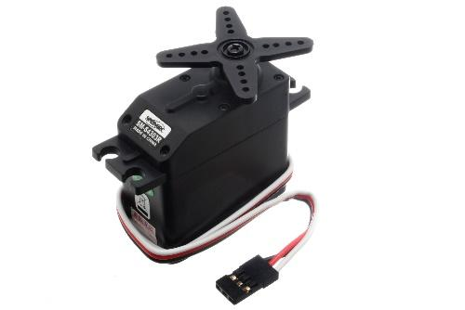

In addition, the high use of this type of motor in the industry allows us to easily choose the most suitable type of servo motor.

Indeed, after some research, the available models that we have chosen would be: the MG996R present in figure 2.6 with a weight of 55g, a rotation of up to 120° and a stall torque of 11kg/cm with a speed of 0.14s /60 to 4.8V; or the GS9025MG with a weight of 14g, rotation up to 120° and a stall torque of 2.5kg/cm with a speed of 0.11s/60 at 4.8V

Thus, each of these 2 engines would have the necessary properties for the Poly-Snake.

**III.4. Battery selection**

We will focus in this part on the choice of the battery that will be used as a power supply for our project. To follow our specifications, the battery selected must be able to supply a voltage of at least 6V, [4066;6100] mAh taking into account the sensor and the servomotors which consume the most and finally all while being quite light to reduce the weight and therefore the energy to be provided to the robot to be able to move forward.

Thus, our choices fell on the following 4 batteries: Li-ion Cell presented in figure 2.7, Wltoys, Pololu and finally the Zop Power of which here is a summary table of the characteristics:

| Battery | Li-ion Cell | Wltoys | Pololu | Zop Power |
| --- | --- | --- | --- | --- |
| Reference | ICR18650 6700mAh 3.7 | K949-78 | 3x2 AA Cells | 11.1V 2200mAh 30C 3S Prise Lipo Batterie XT60 |
| Voltage (V) | 3,7 | 7,4 | 7,2 | 11,1 |
| Ampérage (mAh) | 6700 | 2200 | 2200 | 2200 |
| Number | 2 | 4 | 4 | 4 |
| Target amperage (mAh) | 6700 | 4400 | 4400 | 4400 |
| Target voltage | 7,4 | 7,4 | 7,2 | 11,1 |
| Leght (cm) | 38 | 34 | 43 | 34 |
| Height (cm) | 20 ,5 | 15 | 29 | 24,5 |
| Lenght (cm) | 68,5 | 100 | 51 | 105 |

Thus, this table will allow us to choose the battery best suited to our specifications.

**III.5. Results**

This chapter being particularly dense in information, we have decided to produce a summary table of the components that we have studied and analyzed to facilitate understanding when choosing the components that will take place during the Conclusion.

So, here's what comes out of it:

| Camera |  |
| --- | --- |
| Modele | ‎Pi-Camera-OV5647 |
| Resolution | 1080p |
| Dimension (cm) | 12.7 x 9.1 x 4.3 |
| Weight (g) | 80 |
| Price € | 13,99 |
| Capteur | Ultrasound | Lidar |
| Modele | ‎FR-EL-SM-001 | SEN0413 |
| Dimension (mm) | 45 x 15 x 30 | 42×15×17 |
| Weight (g) | 9 | 4 |
| Resolution (cm) | 0,3 | 0,1 |
| Effective distance (cm) | 2→300 | 20→1200 |
| Price € | 2,09 | 20,67 |

| Engine | DC 3-6V |
| --- | --- |
| Couple (N*m) | 0.15 → 0.60 |
| Speed (tr/min) | 200 |
| Tension (V) | 3→6 |
| Ampere (A) | 0.25→0.73 |
| Dimension (mm) | 67,8x17,8x19,8 |
| Price € | 1,85 |
| Servo | MG996R | GS9025MG |
| Couple (kg*cm) | 11 | 2,5 |
| Speed (sec/60°) | 0,14 | 0,11 |
| Tension (V) | 6 | 6 |
| Ampere (A) | 0,9 | 1 |
| Weight (g) | 55 | 14 |
| Power (W) | 5,4 | 6 |
| P 8 servo (W) | 43,2 | 48 |
| Conso 8 servo (mAh) | 7200 | 8000 |
| Dimension (mm) | 53.6x20x47.6 | 23x12.1x28.8 |
| Price € | 2,18 | 3 |

**Chapter IV : Realization**

**IV.1. Assembly of the robot**

Now that the components have been chosen, to make our project even easier to understand, we will then make a sketch explaining the assembly of the Poly-Snake envisaged where the positioning of the motors, the Arduino board and the battery as well as the arrangement of the servomotors to simulate the movement of a snake.

Here is what emerges:





The components are as follows: in black the servo motors, in yellow the motorization of the wheels, in orange the wheels and in green the 3D printed part allowing the modules to be linked together.

To better imagine the shape of the green room, we took a 3D model represented in figure 3.1 and 3.2 which perfectly summarizes the idea that we wish to implement:



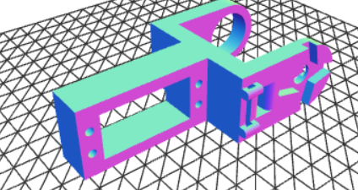

However, it is important to choose the right filament for 3D printing this part to minimize costs and perfect these characteristics. Indeed, depending on the type of filament used, the part can be resistant to rain, heat, friction, etc... and that is why the choice is important.

**IV.2. Filament choice**

Thus, to choose the most suitable filament we will use the following summary table:

Our choice fell on the PETG filament due to these many advantages which would allow us to easily meet our specifications, all at a reduced price.

**IV.3. Final appearance**

Thus, using the previous information, the final layout of our project should look like the image below:

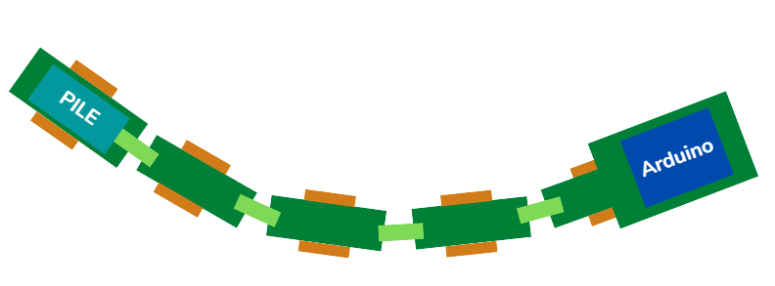

We can note the presence of non-motorized wheels on the last module in order to be able to position the batteries that we will use as well as the larger size for the head module that will therefore require the use of a more powerful motor for the motorization of the wheels due to the greater weight.

**Chapter V : Conception**

**V.1. Strategy**

After having taken an overview of the project and the different aspects that we want to incorporate into it, we will see in this part the strategy that we are going to adopt in order to design our system in the most fluid way or, in other words, as organized as possible.

Thus, our development strategy for the Poly-Snake unfolds along several lines opposite:

* **First strage:** Realization of the first 4 modules

In this first step we will be interested in the start-up of only 4 modules each composed of a servomotor that will be operated using an Arduino card. The objective here is to develop a program to simulate the movement of a snake on a small scale or, in other words, to create a program allowing the 4 modules to wave synchronously (like a real snake)

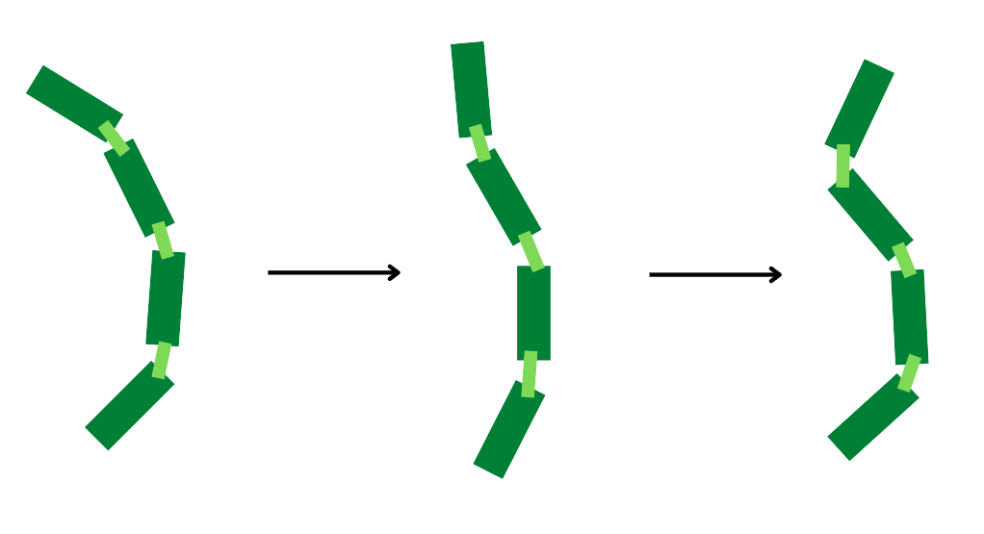

* **Second stage:** Size increase

After having finished programming the movement of the first 4 modules, the next step will consist in designing the entire body of the Poly-Snake composed in all and for all of about ten modules and slightly modifying the previous program in order to approach the original size of a lambda snake which is about thirty centimeters while maintaining its fluidity of movement.

* **Third stage:** Addition and motorization of wheels

Following this, we will focus on adding the wheels as well as the DC motors chosen in the previous chapter to motorize the Poly-Snake. Indeed, these DC motors which are all along the system will allow our robot to move easily on many different types of field.

* **Fourth stage:** Added new components

Finally, once the robot can move freely, we will focus on the more secondary aspects of the robot. In other words, it is at this time that we will begin to add to our project the elements to be studied later, such as the ultrasonic sensor, the camera, or the rectifier, all so that our system becomes as autonomous as possible.

**V.2. Planning**

Thus, from the strategy envisaged previously we can build a schedule in figure 4.1 allowing us to predict the approximate time of each stage and to be able to refer to it.

So, here's what comes out of it:



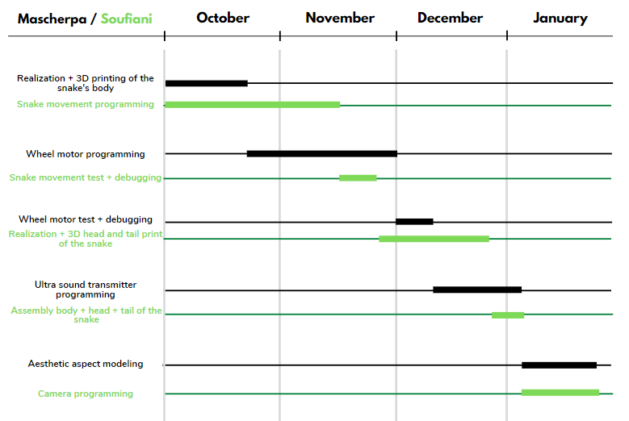

Our primary objective will therefore be to follow this schedule as far as possible to limit delays as much as possible and to be able to finalize our project before the end of the school year.

**Conclusion**

Finally, this bibliography allowed us to choose the essential components of our Poly-Snake project to respect our specifications in addition to allowing us to organize ourselves to produce our robot in a single school year

So, we decided to incorporate the following components into our system:

* An ultrasonic transmitter for its price and sufficient accuracy to locate in space.
* The GS9025MG servomotor due to these characteristics which are more interesting than the other servomotors studied, and which comes very close to our performance criteria and which make it possible to simulate the movement of the snake.
* A Li-ion Cell battery reference ICR18650 6700mAh 3.7 which used in pairs would allow us to operate the Poly-Snake for more than 20min as specified in our requirements and which makes it possible to motorize the wheels of the robot.
* A Pi-Camera-OV5647 camera allows our system to film its environment.
* And finally, the whole connected by a frame printed in 3D by inexpensive PETG filaments, resistant to water and shock and easy to use.

It is important to note here that we have decided to focus on the movement of the Poly-Snake as well as on its ability to locate itself in its environment and that is why we have abandoned certain components such as the rectifier or the lidar SEN0413 which turned out to be too complicated to implement in a single semester in our project.

However, we do not rule out the idea of using them later at the start of 2023 if we have had the opportunity to respect the schedule.

**Useful link:**

[1] Controlling snake-like robots : <https://www.prnewswire.com/news-releases/university-of-electro-communications-e-bulletin-controlling-snake-like-robots-for-high-mobility-and-dexterity-300915812.html>

[2] Bioinspired Robotic Snake : <https://www.instructables.com/Bioinspired-Robotic-Snake/>

[3] Snake Robot : <https://www.instructables.com/Snake-Robot-1/>

[4] Servomotor : <https://fr.aliexpress.com/item/1005002062933764.html?_randl_currency=EUR&_randl_shipto=FR&src=google&src=google&albch=shopping&acnt=248-630-5778&slnk=&plac=&mtctp=&albbt=Google_7_shopping&gclsrc=aw.ds&albagn=888888&isSmbAutoCall=false&needSmbHouyi=false&src=google&albch=shopping&acnt=248-630-5778&slnk=&plac=&mtctp=&albbt=Google_7_shopping&gclsrc=aw.ds&albagn=888888&ds_e_adid=597281422482&ds_e_matchtype=&ds_e_device=c&ds_e_network=u&ds_e_product_group_id=296715514933&ds_e_product_id=fr1005002062933764&ds_e_product_merchant_id=109101819&ds_e_product_country=FR&ds_e_product_language=fr&ds_e_product_channel=online&ds_e_product_store_id=&ds_url_v=2&albcp=17223705741&albag=135335572766&isSmbAutoCall=false&needSmbHouyi=false&aff_fcid=ceab66df79cf48298e000d90b90b9a84-1665184117224-01977-UneMJZVf&aff_fsk=UneMJZVf&aff_platform=aaf&sk=UneMJZVf&aff_trace_key=ceab66df79cf48298e000d90b90b9a84-1665184117224-01977-UneMJZVf&terminal_id=ba50149b70d1493c917608250e704170&afSmartRedirect=y>

[5] ultrasonic transmitter: https://www.robotshop.com/be/fr/module-sonar-hc-sr04-tys.html

[6] Lidar : <https://www.mouser.fr/ProductDetail/DFRobot/SEN0413?qs=ljCeji4nMDnbXic0FTuMLA%3D%3D>

[7] Camera InnoMaker : <https://www.amazon.fr/Inno-Maker-Module-cam%C3%A9ra-Ov5647-pour-Raspberry/dp/B07G9VLPZH/ref=asc_df_B07G9VLPZH/?tag=googshopfr-21&linkCode=df0&hvadid=507115238329&hvpos=&hvnetw=g&hvrand=11114527897834612520&hvpone=&hvptwo=&hvqmt=&hvdev=c&hvdvcmdl=&hvlocint=&hvlocphy=9054943&hvtargid=pla-712748811017&psc=1>

[8] DC motor : https://www.robotshop.com/be/fr/moteur-electrique-dc-3-6v-148-boite-vitesses-magnetique-tt-double-arbre-6x.html